# University of Cambridge Summer School 2019 (Medical Subjects)

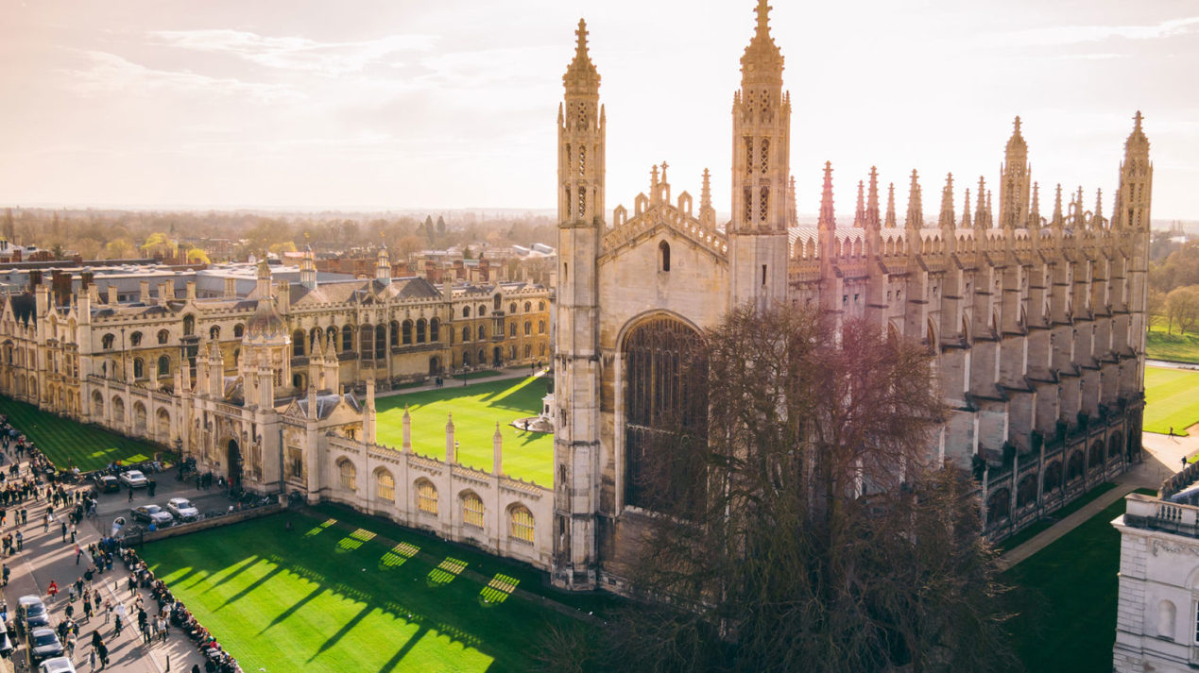

This two-week program is to offer the medical and life-sciences students a brief insight into medical-related subjects and cutting-edge researches, as well as experiencing the Cambridge student life. It will not only prepare the students into later stages of their undergraduate studies but also show them how to be a researcher in medical-related fields.

**Course introductions:**

**Biomedical Sciences – 5 hours**

Biomedical science transforms our understanding of health and disease. This lecture will put students at the cutting edge of science. It covers everything from healthcare issues to research-based science, learning how disease is caused, identified and treated. Topics includes the structure and function of biological fluids, cells and tissues, and the relationship between bodily systems and health, disease and the environment.

**Medical English – 5 hours**

This course focuses on the language of medicine in English, both spoken and written. It is designed to help students master specific medical vocabulary and idioms and to improve their ability to communicate in English in a hospital or clinical setting.

**Tumor Biology – 5 hours**

This course is designed to provide students with a current and comprehensive review of biologic structure and function at the cellular, tissue, and organ system levels. Clinical correlation sessions, which illustrate the contributions of cell biology to specific medical problems, are interspersed in the lecture schedule.

**Neurodegenerative Diseases – 5 hours**

Researches into neurodegenerative diseases are progressing very quickly due to a large patient population worldwide. Many neurodegenerative diseases – including amyotrophic lateral sclerosis, Parkinson's, Alzheimer's, and Huntington's – occur as a result of neurodegenerative processes. The students will learn the mechanisms, therapeutics and cutting age researches in this field.

**Genetics – 2.5 hours**

This lecture discusses the principles of genetics with application to the study of biological function at the level of molecules, cells, and multicellular organisms, including humans. The topics include: structure and function of genes, chromosomes and genomes, biological variation resulting from recombination, mutation, and selection, population genetics, use of genetic methods to analyse protein function, gene regulation and inherited disease.

**DNA sequencing techniques – 2.5 hours**

Students will learn about DNA, genomics, and how DNA sequencing is used. The lecture will introduce the previous technologies such as Sanger sequencing and recent high-throughput sequencing technologies which have revolutionised the study of genomics and molecular biology.

**Academic Writing– 2.5 hours**

This is an early-stage course which provide the foundations needed for clear, accurate and appropriate communication and the language functions needed to writefor the thesis and for publication.The course also focuses on some of the main features of formal scientific writing, including academic style, vocabulary, and text organisation. A series of medical related journals will be introduced to students

**Introduction to Clinical Medicine in Cambridge – 5 hours**

Based on the Cambridge Biomedical Campus and at Cambridge University Hospitals NHS Trust, the Clinical School offers the opportunity to study in one of the most exciting medical centres in the UK, where high quality clinical care is supported by excellent teaching and research.The focus for teaching and learning is patient-centredness, such that students are encouraged to think of medical care from the patients’ perspective throughout. The curriculum is built around a common set of themes, which allow integration of a wide range of medical subjects around core principles of healthcare for the individual and for communities.

**Medical statistics – 5 hours**

This lecture provides an introduction to important topics in medical statistical concepts and reasoning. It will offer students an understanding of basic statistical principles. Real examples from published clinical research literature will be discussed.

**Theoretical Biology and Medical Modelling – 2.5 hours**

Theoretical Biology and Medical Modelling adopts a broad definition of "biology" and focuses on theoretical ideas and models associated with developments in biology and medicine. This lecture covers interrelationships between theoretical and experimental aspects of research, and the roles of modelling and statistics.

**Program Activities:**

**College Garden Party. Health and safety training– 2.5 hours**

Introduction to the programs & activities, meet with the instructors

**Cambridge University History Introduction – 2.5 hours**

The University of Cambridge is a collegiate public research university in Cambridge, England with more than 800 years history.This session will introduce the special collegiate structure of Cambridge University, its long history and stories.

**Cambridge Colleges Tour – 2.5 hours**

Students could explore the most important aspects of the city, University and have internal visits to colleges. Internal visits to colleges. Those interested in Architecture will be able to explore 1000 years of some the finest buildings in the UK, whilst the wealth of scientific history can cover Newton, Darwin, the splitting of the atom and the unravelling of the structure of DNA.

**Cambridge Museums and River Tour – 2.5 hours**

Cambridge is also home to world-class museum collections. The students will visit the most famous museums in Cambridge. The River Cam runs through the heart of Cambridge enabling students to enjoy fantastic views of the world-famous Cambridge College ‘Backs’ from the comfort of a traditional Cambridge Punt.

**Meet with Cambridge Graduate Students with Medical-Related Background – 2.5 hours**

To learn about the research and non-research career path in medical and biomedical fields

**Meet with Cambridge Medical-Related Students with Research experience – 2.5 hours**

To learn about conducting research in medical and biomedical fields and how to apply to be a graduate student in Cambridge University

**English** **Etiquette and Manners (links to College Formal Dinner) – 2.5 hours**

English people have historically been known to place a great deal of importance in good manners. Whether it be in relation to speech, timeliness, body language or dining, politeness is key. Students will learn these etiquette and manners before College Formal Dinner.

**College Formal Dinner – 3 hours**

Formal Hall is a formal meal held at Cambridge University, at which students usually dress in formal attire and often gowns to dine.Students will have this unique opportunity to experience such special formal meal as a closing reception of this whole program.

**Leading teaching staff:**

**Dr. Mark A Holmes MA, VetMB, PhD, FRCVS**

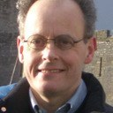

Dr. Holmes is Director of Studies in Clinical Veterinary Medicine (Churchill College) and Reader in Microbial Genomics & Veterinary Science. Dr. Holmes leads a research group whose current focus of research is on antimicrobial resistance. His lab was responsible for the discovery of a new livestock-associated MRSA harboring a mecA homologue (now named mecC). He also has interests in clinical research (including animal welfare) and evidence-based veterinary medicine and has published a number of papers and books in these areas.

**Professor Shervanthi Homer**

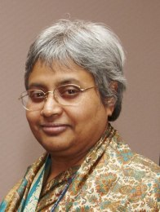

Professor Vanniasinkam was appointed Consultant Vascular Surgeon at The General Infirmary at Leeds in October 1995, having trained in India and the UK. Professor Homer-­‐Vanniasinkam is Clinical Sub-­‐Dean of Leeds Medical School and has significant medical undergraduate teaching and examining commitments. Professor Homer-­‐Vanniasinkam holds office in a number of national and international committees and organizations. She is on the Council of the Vascular Society of Great Britain & Ireland and is the Founding Chair of its Research Committee. She currently holds a number of Visiting Professorships and collaborative appointments in this country and abroad. Recently, Professor Homer-­‐Vanniasinkam has been associated with emerging technologies and their applications in healthcare; she is invited to participate in several national initiatives in this sphere of her work.

**Dr. Jerome Charmet**

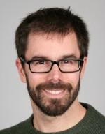

Jerome Charmet is an Assistant Professor at the Institute of Digital Healthcare, WMG, University of Warwick. His vision is to apply advanced engineering methods to develop smart biosensors and biomedical devices. His strategy is to develop a problem-driven research activity at the interface between engineering and medical sciences by collaborating closely with biologists, clinicians and healthcare specialists. He was the recipient of the prestigious 2011 W. D. Armstrong Studentship (engineering for life science) at the University of Cambridge to undertake a PhD on the development of biosensors for point-of-care diagnosis. He was a post-doctoral research associate in the group of Prof. Tuomas P. J. Knowles, Department of Chemistry, University of Cambridge where he developed methods and devices for protein biophysics. He is currently a visiting researcher in the group.

# University of Cambridge Summer School 2019 (Medical Subjects)

|  |  |  |
| --- | --- | --- |
|  | **Morning** | **Afternoon** |
| **Day 1** | Arrival. Check into Cambridge College | College Garden Party.Health and safety training. |
| **Day 2** | Cambridge University History Introduction | Medical English |
| **Day 3** | Biomedical Sciences | Medical English |
| **Day 4** | Biomedical Sciences | Meet with Cambridge Graduate Students with Medical-Related Background |
| **Day 5** | Tumour Biology | Cambridge Colleges Tour |
| **Day 6** | Tumour Biology | Cambridge Museums and River Tour |
| **Day 7** | Trip to Oxford University and BicesterVillage (optional) | |
| **Day 8** | Neurodegenerative Diseases | Neurodegenerative Diseases |
| **Day 9** | Genetics | DNA sequencing techniques |
| **Day 10** | Academic Writing | Meet with Cambridge Medical-Related Students with Research experience |
| **Day 11** | Introduction to Clinical Medicine in Cambridge | Introduction to Clinical Medicine in Cambridge |
| **Day 12** | Medical statistics | Medical statistics |
| **Day 13** | Theoretical Biology and Medical Modelling | English Etiquette and Manners (links to College Formal Dinner) |
| **Day 14** | Trip to London (Optional) | |